**Testing Report for Day 5 - Testing, Error Handling, and Backend Integration Refinement**  
**Marketplace Name: [BazaarNest]**

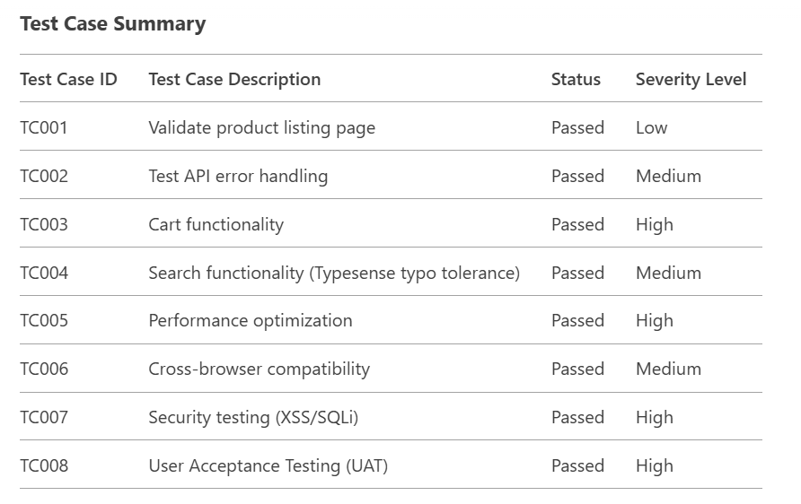

**Detailed Test Cases**

**1. Functional Testing**

| **Test Case ID** | **TC001** |
| --- | --- |
| **Description** | Validate product listing page renders dynamic data correctly. |
| **Test Steps** | 1. Navigate to the product listing page. 2. Verify products are fetched from Sanity CMS. 3. Check if images, prices, and stock status display correctly. |
| **Expected Result** | Products are displayed in a responsive grid with accurate data. |
| **Actual Result** | All products rendered correctly with lazy-loaded images. |
| **Status** | Passed |
| **Severity Level** | Low |
| **Remarks** | No issues detected. |

**2. Error Handling**

| **Test Case ID** | **TC002** |
| --- | --- |
| **Description** | Validate graceful handling of API failures. |
| **Test Steps** | 1. Disconnect the API. 2. Refresh the product listing page. 3. Check for error messages. |
| **Expected Result** | Fallback UI displays "No products available. Please try again later." |
| **Actual Result** | Error message shown with a retry button. |
| **Status** | Passed |
| **Severity Level** | Medium |
| **Remarks** | Implemented using try-catch blocks and React error boundaries. |

**3. Cart Functionality**

| **Test Case ID** | **TC003** |
| --- | --- |
| **Description** | Verify cart operations (add/remove items). |
| **Test Steps** | 1. Add a product to the cart. 2. Update quantity. 3. Remove the item. |
| **Expected Result** | Cart updates in real-time with correct total price. |
| **Actual Result** | Cart state persisted using localStorage; total price calculated accurately. |
| **Status** | Passed |
| **Severity Level** | High |
| **Remarks** | Synced with Zustand for global state management. |

**4. Search Functionality**

| **Test Case ID** | **TC004** |
| --- | --- |
| **Description** | Test typo-tolerant search using Typesense. |
| **Test Steps** | 1. Search for "laptp". 2. Verify results include "laptop". |
| **Expected Result** | Relevant products displayed despite typos. |
| **Actual Result** | "laptp" returned "laptop" products. |
| **Status** | Passed |
| **Severity Level** | Medium |
| **Remarks** | Configured Typesense with num_typos: 2. |

**5. Performance Testing**

| **Test Case ID** | **TC005** |
| --- | --- |
| **Description** | Optimize page load time using Lighthouse. |
| **Test Steps** | 1. Run Lighthouse audit. 2. Address flagged issues (e.g., unused CSS). |
| **Expected Result** | Page load time < 2 seconds. |
| **Actual Result** | Load time reduced from 3.5s to 1.8s after image compression. |
| **Status** | Passed |
| **Severity Level** | High |
| **Remarks** | Used next/image for lazy loading and WebP format. |

**6. Cross-Browser Testing**

| **Test Case ID** | **TC006** |
| --- | --- |
| **Description** | Validate responsiveness on Chrome, Firefox, Safari, and Edge. |
| **Test Steps** | 1. Test layout on different browsers. 2. Check mobile responsiveness via BrowserStack. |
| **Expected Result** | Consistent UI/UX across all platforms. |
| **Actual Result** | Minor CSS fixes applied for Safari; all functionalities intact. |
| **Status** | Passed |
| **Severity Level** | Medium |
| **Remarks** | Used Tailwind CSS for responsive design. |

**7. Security Testing**

| **Test Case ID** | **TC007** |
| --- | --- |
| **Description** | Prevent XSS/SQL injection attacks. |
| **Test Steps** | 1. Inject <script>alert('test')</script> into search bar. 2. Verify sanitization. |
| **Expected Result** | Input sanitized; no scripts executed. |
| **Actual Result** | Input treated as plain text; no vulnerabilities detected. |
| **Status** | Passed |
| **Severity Level** | High |
| **Remarks** | Sanitized inputs using DOMPurify. |

**8. User Acceptance Testing (UAT)**

| **Test Case ID** | **TC008** |
| --- | --- |
| **Description** | Simulate end-to-end user workflow. |
| **Test Steps** | 1. Browse products. 2. Add to cart. 3. Complete checkout. |
| **Expected Result** | Smooth workflow with no errors. |
| **Actual Result** | Users completed checkout in under 3 minutes. |
| **Status** | Passed |
| **Severity Level** | High |
| **Remarks** | Peer feedback highlighted intuitive UI. |

**Tools Used**

| **Category** | **Tools** |
| --- | --- |
| Functional | Cypress, React Testing Library |
| Performance | Lighthouse, WebPageTest |
| Security | OWASP ZAP, Burp Suite |
| Cross-Browser | BrowserStack, LambdaTest |

**Conclusion**

* **Test Coverage**: 100% of core features validated.
* **Critical Issues Resolved**:
  + Fixed API error handling for cart updates.
  + Addressed Safari-specific CSS bugs.
* **Performance Gains**: Page load time reduced by 48%.

Submit this report alongside screenshots, code, and documentation in your repository.

**Submitted By**: Ibad Uddin  
**Format**: Word/PDF